TIDAL TIMES NOVEMBER-DECEMBER 2025 NEWSLETTER
TABLE OF CONTENTS: Page 1. Event Calendar; Page 2. Interview; Page 3. Social Rec; Page 4-Recipes
EVENT CALENDAR
NOVEMBER 2025
Cellobop, 2:00 PM Sunday November 2nd, Raymond Theatre, Raymond, WA
Sips and Bricks @ Willapa Brewing Co., 6-7PM Tuesday November 4th, South Bend, WA
Thanksgiving Party, 2:00 PM Thursday November 27th at Willapa Harbor Chamber of Commerce, South Bend, WA
DECEMBER 2025
Crab Pot Christmas Tree Lighting- 4:00 PM Saturday December 6th, Port of Ilwaco, Ilwaco, WA
Holiday Market-10:00AM-3:00PM Saturday December 13th, Port of Ilwaco, Ilwaco, WA
Adult and Teen Lego Club- 3:00-4:30 PM Tuesday December 16th, Aberdeen Timberland Library, Aberdeen, WA

Jessica Verboomen Interview
- What is your job and what does it entail? I am the Deputy Director; I oversee all of the programs provided by the Health Department but I am heavily involved in the behavioral health systems and programs provided by our county.

- Was this your dream job growing up? If not, what was? My dream job was to help people and I do feel like I get to do a lot of that, every day.

- What is your favorite dessert, if you have one? A warm brownie with cold vanilla ice cream!

- What is one thing people don’t know about Jessica Verboomen? Even though I am very loud in my work, when I go home, I like to sit in silence for long periods of time.
- What does a perfect day look like to you? A stormy day with rain and wind, my house is clean and laundry is done, candles and fireplace lit, nowhere to go and my whole family is home watching Harry Potter.
- Your least favorite household chore is what? Vacuuming, I hate it.
- How would friends describe Jessica Verboomen? Loyal, loud, and passionate
- Name one thing you are good at and one thing you need to improve on. I am good at organization but need to improve on doing a little bit of something every day, instead of trying to do a lot all at once.
- What is your favorite season? Fall/Winter
- If you could go anywhere in the world, where would it be and why? England or Scotland, I’ve always been fascinated by the architecture and the history. 

November 21st- Holiday Shopping in Astoria/Warrenton
On Friday November 21st, we will be heading to Astoria/Warrenton for some Christmas shopping. We will first meet up at South Bend Health Department at 9:00 to head towards Astoria. We will then go to Walmart and Fred Meyer’s in Warrenton to do some shopping. Next will be Fultano’s Pizza in Warrenton for the lunch buffet, and finally we will do a little walk around Astoria and head back to South Bend. We should be leaving Astoria around 1:30-2PM, so that will get us back to the Health Department between 2:30-3:00PM. Please bring around $35 to $40 (at least $13 for the buffet and the rest for Christmas shopping) and please have transportation to and from South Bend Health Department.
For any clients who reside on the Long Beach Peninsula that wish to join any Social Rec. events, please call Jenny Penoyar or Claudia Mimna by phone or email (jpenoyar@co.pacific.wa.us, 360-875-9343 x2631; cmimna@co.pacific.wa.us, 360-875-9343 x2626)

December 19th- Lunch/Christmas Cookie Making
On Friday December 19th, we will be heading to the Hungry Heifer in Raymond for Lunch and then head to the Raymond Senior Center to make some Christmas cookies and do some activities. We will meet up at 1:00 PM at the Hungry Heifer to eat and then will head to the Raymond Senior Center at 2:00 to start baking some cookies. While cookies are baking, we will play some games, color, and do some other holiday activities. Once cookies are finished, we will clean up and leave around 4:00 PM or so. Please bring $20 for lunch and have transportation to Hungry Heifer and from Raymond Senior Center.
For any clients who reside on the Long Beach Peninsula that wish to join any Social Rec. events, please call Jenny Penoyar or Claudia Mimna by phone or email (jpenoyar@co.pacific.wa.us, 360-875-9343 x2631; cmimna@co.pacific.wa.us, 360-875-9343 x2626)
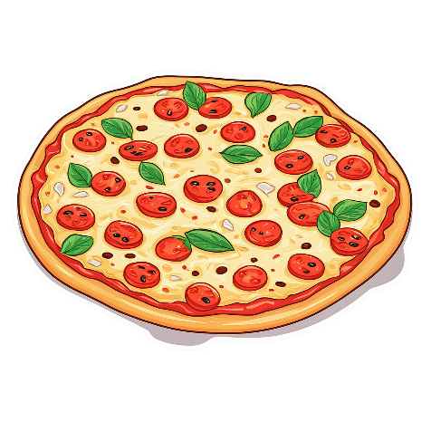

Ingredients
- 1 14.3 oz. package Golden Oreos
- 1 8 oz. block of cream cheese, softened
- 1 tsp. vanilla extract
- 12 oz. white melting chocolate
- Sprinkles
Instructions
- In a food processor, add Oreos and process until fine crumbs.
- Transfer to a bowl and add cream cheese (broken up into small pieces) and vanilla. I am going to say use a spoon to combine well but what I really mean is use your hands, hands work best here. Just make sure they are washed.
- Roll into small, bite sized balls. For best results, freeze for about 10-15 minutes.
- Melt white chocolate using either double boiler method or package instructions. Roll each truffle in chocolate to coat evenly and place on parchment paper. Sprinkle with desired color of sprinkles.
- Repeat with remaining balls and allow to cool and dry before eating or don’t. Store in the fridge for up to one week
Christmas Golden OREO Truffles By Lorie Yarro
Ingredients
- 2 Tbsp. butter
- 2 large carrots, peeled and sliced into coins
- 1 stalk celery, chopped
- Kosher salt
- Freshly ground black pepper
- 3 cloves garlic, minced
- 1 Tbsp. All-purpose flour
- 1 ½ lb. boneless skinless chicken breasts
- 3 sprigs fresh thyme
- 1 bay leaf
- ¾ lb. baby potatoes, quartered
- 3 cups low-sodium chicken broth
- Freshly chopped parsley, for garnish
Instructions
- In a large pot over medium heat, melt butter. Add carrots and celery and season with salt and pepper. Cook, stirring often, until vegetables are tender, about 5 minutes. Add garlic and cook until fragrant, about 30 seconds.
- Add flour and stir until vegetables are coated, then add chicken, thyme, bay leaf, potatoes, and broth. Season with salt and pepper. Bring mixture to a simmer and cook until the chicken is no longer pink and potatoes are tender, 15 minutes.
- Remove from heat and transfer chicken to a medium bowl. Using two forks, shred chicken into small pieces and return to pot.
- Garnish with parsley before serving.
Chicken Stew by Lauren Miyashiro

